

**Compassion Resilience:**

**A Toolkit for Schools and Health & Human Service organizations**

**Facilitator/Administrator Training**

***Co-sponsored by Brillion School District***

July 25th, 8:30-3:00

Brillion High School, W1101 Co Rd HR, Brillion, WI

**We want to show up strong and compassionate every day.**

Compassion Fatigue is normal response when we care about people in distress.

We work in a context that is always evolving, and this can be challenging.

Help yourself and your colleagues by learning the skills and supports that build resilience.

As leaders, empower your staff to manage the daily stresses of the teaching and helping professions.

Bottom line?

Attract, support and retain the best people for Wisconsin’s children, adults and families.

**The Compassion Resilience Toolkit** is a flexibly implemented set of resources to build awareness of compassion fatigue and strategies to increase compassion resilience in all staff from a system and individual perspective. The resources include activities for guided all-staff, small group or team-based use as well as for individual reflection. The 12 sections include activities for leaders and staff on realistic expectations, setting compassionate boundaries, building a staff culture of compassion, self-care strategies, and links to further learning.

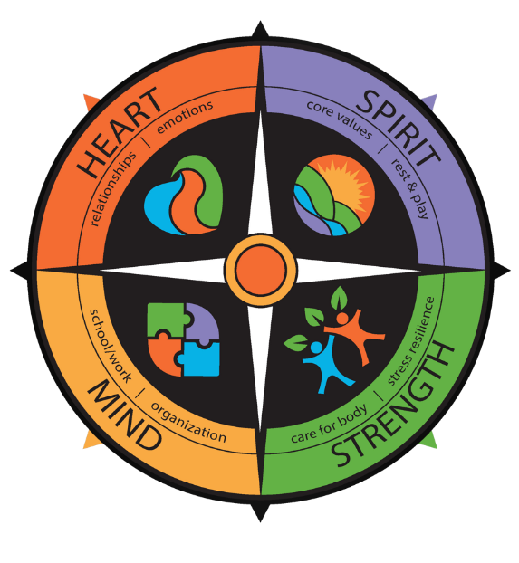**The Training of Facilitators and the Administrative Leader** prepares you to bring the toolkit resources to your colleagues. Attend as a team to ideally include at least: one administrator and 2-3 people who will facilitate with staff. The day includes clarification of leadership roles, rationale for the work, a look at how to inspire culture change through the toolkit, and tips for implementing the toolkit resources matched to the realities of your current organizational commitments and goals.

***The materials are easily accessed and free!***

[www.compassionresiliencetoolkit.org](http://www.compassionresiliencetoolkit.org)

**REGISTER your team for July 25th facilitator team training**

by emailing Megan at: [megan.littel@rogershospital.org](mailto:megan.littel@rogershospital.org)

Cost: $200.00 per team plus $12/person for lunch (lunch to be paid separately day of; rsvp required via Megan)

cid:image004.png@01D4D283.2224E8E0Developed in partnership with: